**Personal and University Projects**

This is a portfolio of some of the most significant personal projects and university related course projects that I have undertaken.

**Space Themed Holiday Website**

Type: individual Timeframe: 2021-sem1

As a part of a design course, I enrolled in, we were required to develop a website with the theme of holidays. I created the website using pure HTML, CSS and JavaScript. I learnt a lot about UX design and HCI (human computer interactions) from this course and I am very proud of the website I created in the end. The website features multiple webpages and all the images used were either self-created or royalty-free. Other than form validation and a simple quiz, no backend process was considered as the onus of the course was on design.

**Please check out the website at:** [**https://peter-tr.github.io/**](https://peter-tr.github.io/) **and the design portfolio and code at:** [**https://github.com/peter-tr/peter-tr.github.io**](https://github.com/peter-tr/peter-tr.github.io)

**“Ragnarök” Endless Runner Game**

Type: team Timeframe: 2021-sem2

In the second semester of 2021, I partook in a course where the objective was for the whole class to work on and develop a game. This was called “Ragnarök” and was written in Java using the Libgdx game engine. Using the link below, the game can be cloned and played. My main contribution to the game was the main enemy, bug fixes, special effects and documentation in wiki.

You can see what I actually did by looking at the commit history for my GitHub tag ‘peter-tr’.

**Please check out the game and code at:** [**https://github.com/UQdeco2800/2021-studio-1**](https://github.com/UQdeco2800/2021-studio-1)

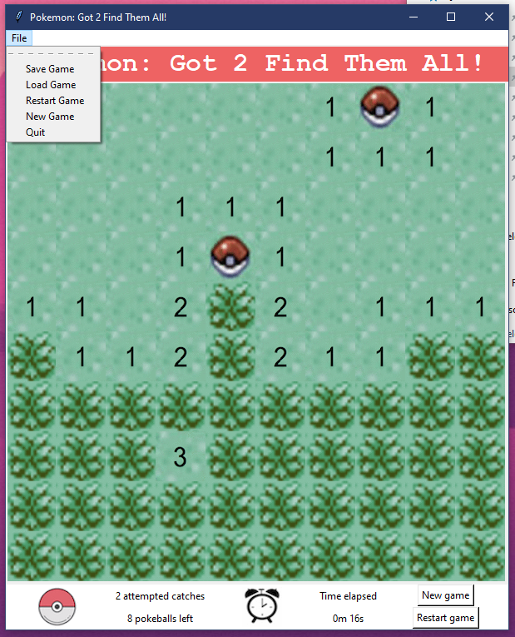**“Pokemon” themed Minesweeper Game**

Type: individual Timeframe: 2020-sem1

For the final assignment of my first coding course in university, I recreated the game Minesweeper in python with a “Pokemon” theme. The game was created from scratch, including the front end aspects (GUI, layout) and the back end processes (mechanics, file system). This course was my first real usage and experience with python and taught me a significant amount about the software design process. The game worked perfectly and featured an interactive GUI and the player’s progress can be saved to a file and loaded.

Code can be upload to GitHub upon request.

**Top-Down Shooter Game**

Type: individual Timeframe: 2019-sem1

During high school, as part of a personal project and school assignment, I created a web-based game that was basically a top-down shooter. As my first ever coding project, I relied heavily on the fun and fast JavaScript game engine called Phaser. Although the game had a lot of bugs, this project is what sparked my interest in software engineering. Throughout the process, I gained experience with CSS, HTML and most notably Javascript.